Basic SQL

6.1 SQL Data Definition and Data Types

6.1.1 Schema in SQL

- Schema elements include tables, constraints, views, domains, and other constructs (such as authorization grants) that describe the schema.

- A schema is created via the CREATE SCHEMA statement, which can include all the schema elements’ definitions.
- For example, the following statement creates a schema called COMPANY, owned by the user with authorization identifier ‘Jsmith’.

CREATE SCHEMA COMPANY AUTHORIZATION ‘Jsmith’;

6.1.2 The CREATE TABLE Command in SQL

- The CREATE TABLE command is used to specify a new relation by giving it a name and specifying its attributes and initial constraints.

- The attributes are specified first, and each attribute is given a name, a data type to specify its domain of values, and any attribute constraints, such as NOT NULL.

- The key, entity integrity, and referential integrity constraints can be specified within the CREATE TABLE statement after the attributes are declared, or they can be added later using the ALTER TABLE command.

CREATE TABLE COMPANY.EMPLOYEE

rather than

CREATE TABLE EMPLOYEE

6.1.3 Attribute Data Types and Domains in SQL

- Numeric :

  - Thedata types include integer numbers of various sizes INTEGER or INT, and

SMALLINT

  - Floating-point numbers of various precision FLOAT or REAL.

  - Formatted numbers can be declared by using DECIMAL(i,j)—or DEC(i,j) or NUMERIC(i,j)—where i, the precision, is the total number of decimal digits and j, the scale, is the number of digits after the decimal point.

- Character-string

  - The data types with fixed length characters—CHAR(n) or CHARACTER(n), where n is the number of characters

  - The data types with varying length characters VARCHAR(n) or CHAR VARYING(n) or CHARACTER VARYING(n), where n is the maximum number of characters.

  - For example, if the value ‘Smith’ is for an attribute of type CHAR(10), it is padded with five blank characters to become ‘Smith ’ if needed. Padded blanks are generally ignored when strings are compared.

  - Another variable-length string data type called CHARACTER LARGE OBJECT or CLOB is also available to specify columns that have large text values, such as documents. The CLOB maximum length can be specified in kilobytes (K), megabytes (M), or gigabytes (G). For example, CLOB(20M) specifies a maximum length of 20 megabytes

- Bit-string

  - The data types of fixed length n is BIT(n).

  - The varying length is BIT VARYING(n), where n is the maximum number of bits.

  - Literal bit strings are placed between single quotes but preceded by a B to distinguish them from character strings; for example, B‘10101’.

  - Another variable-length bit-string data type called BINARY LARGE OBJECT or BLOB is also available to specify columns that have large binary values, such as images

- Boolean

  - Thedata type has the traditional values of TRUE or FALSE. In SQL, because of the presence of NULL values, a three-valued logic is used, so a third possible value for a Boolean data type is UNKNOWN.

- DATE

  - The data type has ten positions, and its components are YEAR, MONTH, and DAY in the form YYYY-MM-DD.

  - The TIME data type has at least eight positions, with the components HOUR, MINUTE, and SECOND in the form HH:MM:SS. for example, DATE ‘2008-09- 27’ or TIME ‘09:12:47’

- Timestamp

  - The data type (TIMESTAMP) includes the DATE and TIME fields.

  - Example, TIMESTAMP ‘2008-09-27 09:12:47.648302’.

6.2 Specifying Constraints in SQL

6.2.1 Specifying Attribute Constraints and Attribute Defaults

- SQL allows NULLs as attribute values, a constraint NOT NULL may be specified if NULL is not permitted for a particular attribute.
- It is also possible to define a default value for an attribute by appending the clause DEFAULT <value> to an attribute definition.

- The default value is included in any new tuple if an explicit value is not provided for that attribute.

- If no default clause is specified, the default default value is NULL for attributes that do not have the NOT NULL constraint.

- Another type of constraint that can restrict attribute or domain values is by using the CHECK clause following an attribute or domain definition.

- For example, suppose that department numbers are restricted to integer numbers between 1 and 20; then, we can change the attribute declaration of Dnumber in the DEPARTMENT table to the following:

Dnumber INT NOT NULL CHECK (Dnumber > 0 AND Dnumber < 21);

- The CHECK clause can also be used in conjunction with the CREATE DOMAIN statement. For example,

CREATE DOMAIN D_NUM AS INTEGER

CHECK (D_NUM > 0 AND D_NUM < 21);

6.2.2 Specifying Key and Referential Integrity Constraints

- The PRIMARY KEY constraint uniquely identifies each record in a database table. Primary keys must contain unique values, and cannot contain NULL values. A table can have only one primary key, which may consist of single or multiple fields.

- For example, the primary key of DEPARTMENT can be specified as

Dnumber INT PRIMARY KEY;

- The UNIQUE clause specifies alternate (secondary) keys, The UNIQUE constraint ensures that all values in a column are different. Both the UNIQUE and PRIMARY KEY constraints are similar .A table can have many UNIQUE constraints , but only one PRIMARY KEY constraint per table.

- The UNIQUE clause can also be specified directly for a secondary key if the secondary key is a single attribute, as in the following example: Dname VARCHAR(15) UNIQUE;

Example:

CREATE TABLE DEPARTMENT

(

Dname VARCHAR(15) NOT NULL,

Dnumber INT NOT NULL,

Mgr_ssn CHAR(9) NOT NULL,

Mgr_start_date DATE,

PRIMARY KEY (Dnumber),

UNIQUE (Dname),

FOREIGN KEY (Mgr_ssn) REFERENCES EMPLOYEE(Ssn)

);

- Referential integrity is specified via the FOREIGN KEY.

- A FOREIGN KEY is a key used to link two tables together. A FOREIGN KEY is a field (or collection of fields) in one table that refers to the PRIMARY KEY in another table.

The table containing the foreign key is called the child table, and the table containing the candidate key is called the referenced or parent table.

- A referential integrity constraint can be violated when tuples are inserted or deleted, or when a foreign key or primary key attribute value is modified.

- The default action that SQL takes for an integrity violation is to reject the update operation that will cause a violation, which is known as the RESTRICT option.
- The schema designer can specify an alternative action to be taken by attaching a referential triggered action clause to any foreign key constraint. The options include SET NULL, CASCADE, and SET DEFAULT. An option must be qualified with either ON DELETE or ON UPDATE.

FOREIGN KEY (Super_ssn) REFERENCES EMPLOYEE(Ssn) ON DELETE SET NULL ON UPDATE CASCADE.

- The database designer chooses ON DELETE SET NULL and ON UPDATE CASCADE for the foreign key Super_ssn of EMPLOYEE. This means that if the tuple for a supervising employee is deleted, the value of Super_ssn is automatically set to NULL for all employee tuples that were referencing the deleted employee tuple.
- On the other hand, if the Ssn value for a supervising employee is updated the new value is cascaded to Super_ssn for all employee tuples referencing the updated employee tuple.

- In general, the action taken by the DBMS for SET NULL or SET DEFAULT is the same for both ON DELETE and ON UPDATE: The value of the affected referencing attributes is changed to NULL for SET NULL and to the specified default value of the referencing attribute for SET DEFAULT. The action for CASCADE ON DELETE is to delete all the referencing tuples, whereas the action for CASCADE ON UPDATE is to change the value of the referencing foreign key attribute(s) to the updated (new) primary key value for all the referencing tuples.

6.2.3 Giving Names to Constraints

- Constraint may be given a constraint name, following the keyword CONSTRAINT.

- The names of all constraints within a particular schema must be unique.

• A constraint name is used to identify a particular constraint in case the constraint must be dropped later and replaced with another constraint,

Example: CONSTRAINT DEPTMGRFK FOREIGN KEY (Mgr_ssn) REFERENCES EMPLOYEE(Ssn)

DEPTMGRFK is a constraint name

6.2.4 Specifying Constraints on Tuples Using CHECK

- Constraints can be specified through additional CHECK clauses at the end of a CREATE TABLE statement.

- These can be called tuple-based constraints because they apply to each tuple individually and are checked whenever a tuple is inserted or modified.

- For example, suppose that the DEPARTMENT table has additional attribute Dept_create_date, which stores the date when the department was created. Then we could add the following CHECK clause at the end of the CREATE TABLE statement for the DEPARTMENT table to make sure that a manager’s start date is later than the department creation date.

CHECK (Dept_create_date <= Mgr_start_date);

6.3 Basic Retrieval Queries in SQL

6.3.1 The SELECT-FROM-WHERE Structure of Basic SQL Queries

- The basic form of the SELECT statement is formed of the three clauses SELECT, FROM, and WHERE .

SELECT <attribute list> FROM <table list> WHERE <condition>;

where

<attribute list> is a list of attribute names whose values are to be retrieved by the query. <table list> is a list of the relation names required to process the query.
<condition> is a conditional (Boolean) expression that identifies the tuples to be retrieved by the query.

- In SQL, the basic logical comparison operators for comparing attribute values with one another and with literal constants are =, <, <=, >, >=, and <>. These correspond to the relational algebra operators =, <, ≤, >, ≥, and ≠, respectively,

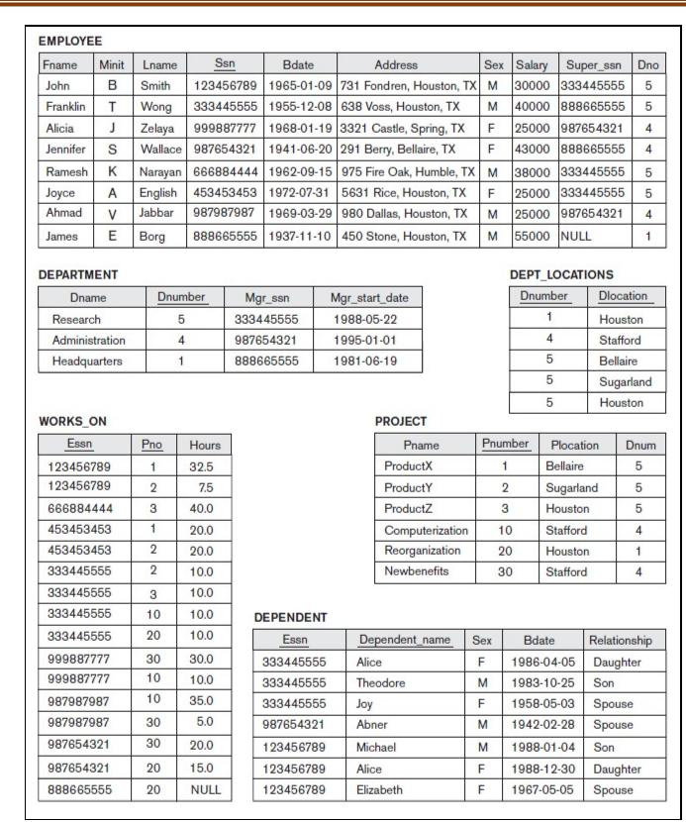

Query 1. Retrieve the birth date and address of the employee(s) whose name is ‘John B.

Smith’.

SELECT Bdate, Address

FROM EMPLOYEE

WHERE Fname=‘John’ AND Minit=‘B’ AND Lname=‘Smith’;


Query 2. Retrieve the name and address of all employees who work for the ‘Research’ department.
SELECT Fname, Lname, Address

FROM EMPLOYEE, DEPARTMENT

WHERE Dname=‘Research’ AND Dnumber=Dno;
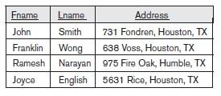

Query 3. For every project located in ‘Stafford’, list the project number, the controlling department number, and the department manager’s last name, address, and birth date.

SELECT Pnumber, Dnum, Lname, Address, Bdate

FROM PROJECT, DEPARTMENT, EMPLOYEE

WHERE Dnum=Dnumber AND Mgr_ssn=Ssn AND Plocation=‘Stafford’;
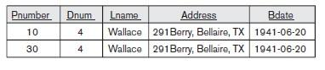

6.3.2 Ambiguous Attribute Names, Aliasing, Renaming, and Tuple Variables

- In SQL, the same name can be used for two (or more) attributes as long as the attributes are in different relations.

- When a multi-table query refers to two or more attributes with the same name, we must qualify the attribute name with the relation name to prevent ambiguity.
- This is done by prefixing the relation name to the attribute name and separating the two by a period.

- To illustrate consider the Dno and Lname attributes of the EMPLOYEE relation were called Dnumber and Name, and the Dname attribute of DEPARTMENT was also called Name; then, to prevent ambiguity we need to prefix the attribute with relation name.

SELECT Fname, EMPLOYEE.Name, Address

FROM EMPLOYEE, DEPARTMENT

WHERE

DEPARTMENT.Name=‘Research’ANDDEPARTMENT.D number =EMPLOYEE.Dnumber;

- For each employee, retrieve the employee’s first and last name and the first and last name of his or her immediate supervisor.

SELECT E.Fname, E.Lname, S.Fname, S.Lname

FROM EMPLOYEE AS E, EMPLOYEE AS S

WHERE E.Super_ssn=S.Ssn;
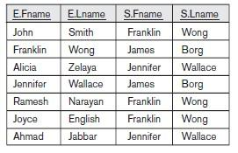

6.3.3 Unspecified WHERE Clause and Use of the Asterisk.

- A missing WHERE clause indicates no condition on tuple selection; hence, all tuples of the relation specified in the FROM clause qualify and are selected for the query result. If more than one relation is specified in the FROM clause and there is no WHERE clause, then the CROSS PRODUCT all possible tuple combinations of these relations is selected.
- For example, Query 9 selects all EMPLOYEE Ssns and Query 10 selects all combinations of an EMPLOYEE Ssn and a DEPARTMENT Dname, regardless of whether the employee works for the department or not

(Q9) SELECT Ssn

FROM EMPLOYEE;

(Q10) SELECT Ssn, Dname

FROM EMPLOYEE, DEPARTMENT;

- To retrieve all the attribute values of the selected tuples, we do not have to list the attribute names explicitly in SQL; we just specify an asterisk (*), which stands for all the attributes. For example, query Q1C retrieves all the attribute values of any EMPLOYEE who works in DEPARTMENT number 5.

Q1C: SELECT *

FROM EMPLOYEE WHERE Dno=5;
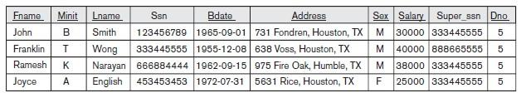

6.3.4 Tables as Sets in SQL

- SQL usually treats a table not as a set but rather as a multiset, duplicate tuples can appear more than once in a table, and in the result of a query.

- SQL does not automatically eliminate duplicate tuples in the results of queries, for the following reasons:

  - Duplicate elimination is an expensive operation. One way to implement it is to sort the tuples first and then eliminate duplicates.

  - The user may want to see duplicate tuples in the result of a query.

  - When an aggregate function is applied to tuples, in most cases we do not want to eliminate duplicates.

- To eliminate duplicate tuples from the result of an SQL query, we use the keyword DISTINCT in the SELECT clause, meaning that only distinct tuples should remain in the result.
- In general, a query with SELECT DISTINCT eliminates duplicates, whereas a query with SELECT ALL does not. Specifying SELECT with neither ALL nor DISTINCT as in our previous examples is equivalent to SELECT ALL.
- For example, Q11 retrieves the salary of every employee; if several employees have the same salary, that salary value will appear as many times in the result of the query,

Query11. Retrieve the salary of every employee (Q11) and all distinct salary values

(Q11A).

Q11: SELECT ALL Salary

FROM EMPLOYEE;

Q11A: SELECT DISTINCT Salary

FROM EMPLOYEE;

- SQL has some of the set operations, they are set union (UNION), set difference (EXCEPT), and set intersection (INTERSECT) operations.

- The relations resulting from these set operations are sets of tuples; that is, duplicate tuples are eliminated from the result.

Query4. Make a list of all project numbers for projects that involve an employee whose last name is ‘Smith’, either as a worker or as a manager of the department that controls the project.

( | SELECT DISTINCT |  | Pnumber
 | FROM | PROJECT, DEPARTMENT, EMPLOYEE
 | WHERE Dnum=Dnumber AND Mgr_ssn=Ssn AND Lname=‘Smith’
)
UNION
( | SELECT | DISTINCT Pnumber
 | FROM PROJECT, WORKS_ON, EMPLOYEE
 | WHERE | Pnumber=Pno AND Essn=Ssn AND Lname=‘Smith’

);

- SQL also has corresponding multiset operations, which are followed by the keyword ALL (UNION ALL, EXCEPT ALL, INTERSECT ALL). Their results are multisets (duplicates are not eliminated).

- The behavior of these operations is illustrated by the examples in Figure 6.5.
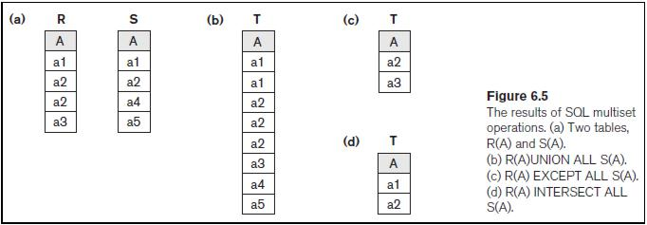

6.3.5 Substring Pattern Matching and Arithmetic Operators

- The LIKE operator is used in a WHERE clause to search for a specified pattern in a column.

- There are two wildcards used in conjunction with the LIKE operator:

  - % The percent sign represents zero, one or multiple characters.

    - _The underscore represents a single character.

Query12. Retrieve all employees whose address is in Houston, Texas.

SELECT Fname, Lname

FROM EMPLOYEE

WHERE Address LIKE ‘%Houston,TX%’ ;

Query 12A. Find all employees who were born during the 1950s.

SELECT Fname, Lname

FROM EMPLOYEE

WHERE Bdate LIKE ‘_ _ 5 _ _ _ _ _ _ _’ ;

- If an underscore or % is needed as a literal character in the string, the character should be preceded by an escape character( ‘\’), which is specified after the string . For example, ‘AB\_CD\%EF’ is used to represent the literal string ‘AB_CD%EF’ .
- The standard arithmetic operators for addition (+), subtraction (–), multiplication (*), and division (/) can be applied to numeric values or attributes with numeric domains. For example, suppose that we want to see the effect of giving all employees who work on the

‘ProductX’ project a 10 percent raise;

Query13. Show the resulting salaries if every employee working on the ‘ProductX’ project is given a 10 percent raise.

SELECT E.Fname, E.Lname, 1.1 * E.Salary AS Increased_sal

FROM EMPLOYEE AS E, WORKS_ON AS W, PROJECT AS P

WHERE E.Ssn=W.Essn AND W.Pno=P.Pnumber AND P.Pname=‘ProductX’;

Query 14. Retrieve all employees in department 5 whose salary is between $30,000 and

$40,000.

SELECT *

FROM EMPLOYEE

WHERE (Salary BETWEEN 30000 AND 40000 ) AND Dno = 5;

6.3.6 Ordering of Query Results

- The ORDER BY keyword is used to sort the result-set in ascending or descending order.

- The ORDER BY keyword sorts the records in ascending order by default. To sort the records in descending order, use the DESC keyword. The keyword ASC can be used to specify ascending order.

- Query 15. Retrieve a list of employees and the projects they are working on, ordered by department and, within each department, ordered alphabetically by last name, then first name.

SELECT D.Dname, E.Lname, E.Fname, P.Pname

FROM DEPARTMENT D, EMPLOYEE E, WORKS_ON W, PROJECT P WHERE D.Dnumber= E.Dno AND E.Ssn= W.Essn AND W.Pno= P.Pnumber ORDER BY D.Dname, E.Lname, E.Fname;

6.3.7 Discussion and Summary of Basic SQL Retrieval Queries.

- A simple retrieval query in SQL can consist of up to four clauses, but only the first two SELECT and FROM—are mandatory. The clauses are specified in the following order, with the clauses between square brackets [ ... ] being optional:

SELECT <attribute list> FROM <table list>
[ WHERE <condition> ]

[ ORDER BY <attribute list> ];

6.4 INSERT, DELETE, and UPDATE Statements in SQL

•In SQL, three commands can be used to modify the database: INSERT, DELETE, and

UPDATE.

6.4.1 The INSERT Command

- INSERT is used to add a single tuple to a relation. We must specify the relation name and a list of values for the tuple.

- While adding values for all the columns of the table, need not specify the column names in the SQL query The values should be listed in the same order in which the corresponding attributes were specified in the CREATE TABLE command.

- The INSERT INTO syntax would be as follows:

INSERT INTO table_name VALUES (value1, value2, value3, ...);

- For example, to add a new tuple to the EMPLOYEE relation shown.

INSERT INTO EMPLOYEE VALUES ( ‘Richard’, ‘K’, ‘Marini’, ‘653298653’, ‘1962-1230’, ’98 Oak Forest, Katy, TX’, ‘M’, 37000, ‘653298653’, 4 );

- The second form of the INSERT statement allows the user to specify explicit attribute names that correspond to the values provided in the INSERT command.

- For example, to enter a tuple for a new EMPLOYEE for whom we know only the Fname, Lname, Dno, and Ssn attributes.

INSERT INTO table_name (column1, column2, column3,...)VALUES (value1, value2, val ue3, ...);
Example:

INSERT INTO EMPLOYEE (Fname, Lname, Dno, Ssn) VALUES (‘Richard’, ‘Marini’, 4, ‘653298653’);

6.4.2 The DELETE Command

- The DELETE command removes tuples from a relation. The WHERE clause, selects the tuples to be deleted. Tuples are explicitly deleted from only one table at a time.

- The deletion propagates to tuples in other relations if referential triggered actions(on delete cascade) are specified in the referential integrity constraints of the DDL.
- A missing WHERE clause specifies that all tuples in the relation are to be deleted; however, the table remains in the database as an empty table. The DROP TABLE command to remove the table definition.

- Example1:

DELETE FROM EMPLOYEE

WHERE Lname=‘Brown’;

Example 2:

DELETE FROM EMPLOYEE;

6.4.3 The UPDATE Command

- The UPDATE command is used to modify attribute values of one or more selected Tuples, the WHERE clause in the UPDATE command selects the tuples to be modified from a single relation.

- Updating a primary key value may propagate to the foreign key values of tuples in other relations if such a referential triggered action(on update cascade) is specified in the referential integrity constraints of the DDL.
- An additional SET clause in the UPDATE command specifies the attributes to be modified and their new values.

  - For example, to change the location and controlling department number of project number 10 to ‘Bellaire’ and 5 respectively.

UPDATE PROJECT

SET Plocation = ‘Bellaire’, Dnum = 5

WHERE Pnumber=10;

- Several tuples can be modified with a single UPDATE command. An example is to give all employees in the ‘Research’ department a 10 percent rise in salary.

UPDATE EMPLOYEE

SET Salary = Salary * 1.1

WHERE Dno = 5;

6.5 Additional Features of SQL

- SQL has various techniques for specifying complex retrieval queries, including nested queries, aggregate functions, grouping, joined tables, outer joins, and recursive queries; SQL views, triggers, and assertions; and commands for schema modification.

- SQL has various techniques for writing programs in various programming languages that include SQL statements to access one or more databases. These include embedded (and dynamic) SQL, SQL/CLI (Call Level Interface) and its predecessor ODBC (Open Data Base Connectivity), and SQL/PSM (Persistent Stored Modules).
- SQL has set of commands for specifying physical database design parameters, file structures for relations, and access paths such as indexes. We called these commands a storage definition language (SDL).
- SQL has transaction control commands. These are used to specify units of database processing for concurrency control and recovery purposes.

- SQL has language constructs for specifying the granting and revoking of privileges to users. Privileges typically correspond to the right to use certain SQL commands to access

certain relations. Each relation is assigned an owner, and either the owner or the DBA staff can grant to selected users the privilege to use an SQL statement—such as SELECT, INSERT, DELETE, or UPDATE—to access the relation. In addition, the DBA staff can grant the privileges to create schemas, tables, or views to certain users. These SQL commands—called GRANT and REVOKE.

- SQL has language constructs for creating triggers. These are generally referred to as active database techniques, since they specify actions that are automatically triggered by events such as database updates.
- SQL has incorporated many features from object-oriented models to have more powerful capabilities, leading to enhanced relational systems known as object-relational.
- SQL and relational databases can interact with new technologies such as XML.

*****

